ADOBE products access: Step-by-step instructions
How to log in to create a TBAISD Adobe ID
- Click the Start Menu -> Adobe Creative Cloud
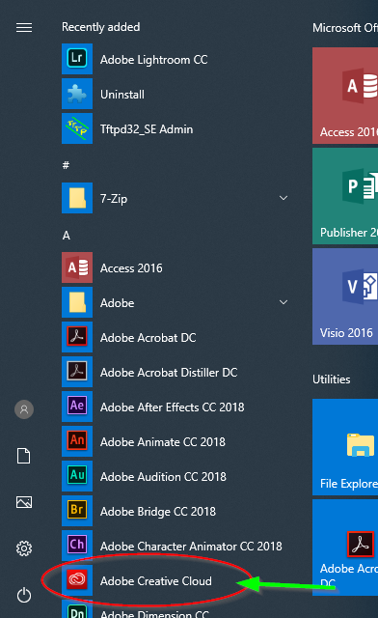

- A dialog box similar to the one below will open. click on the ‘Sign in with an Enterprise ID’ hyperlink
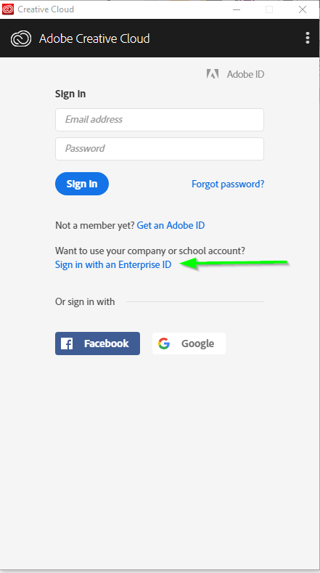
- Enter your email address first. You will be prompted to enter your password later.
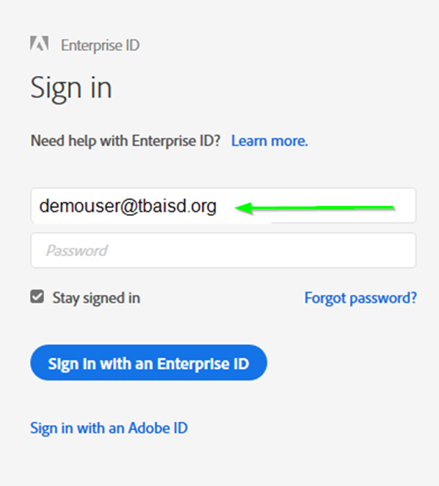

- Please select “Enterprise ID” option and select the TBAISD account.
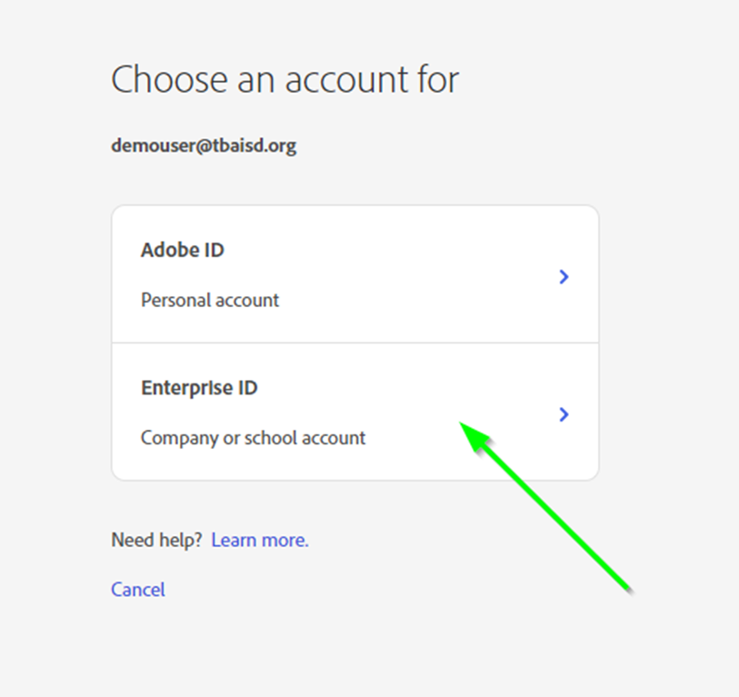

- When the TBAISD dialog box pops up, enter your email address and password and click ‘OK’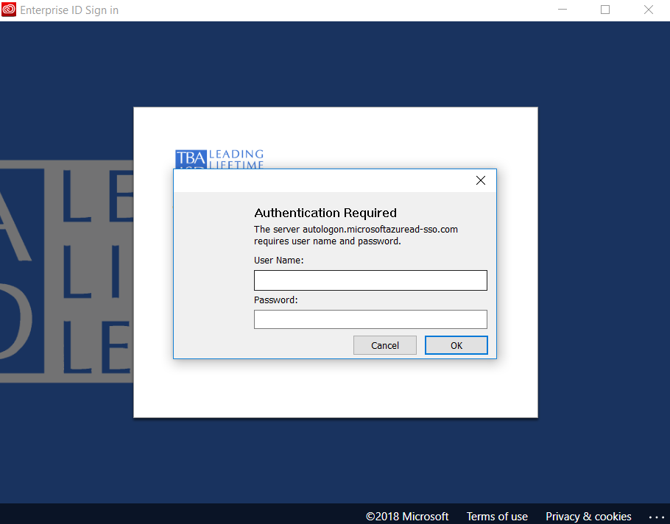

- Enter your email address again in the new browser window and click ‘Next’
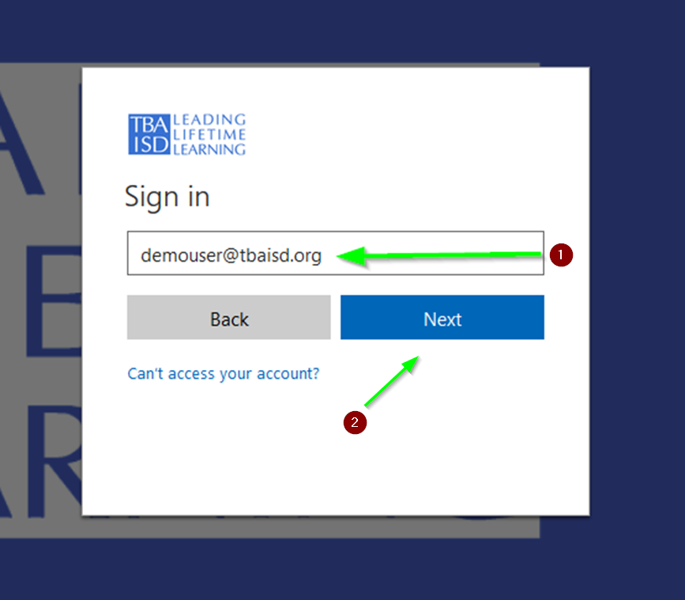
- Enter your password in the next window and click ‘Sign in’
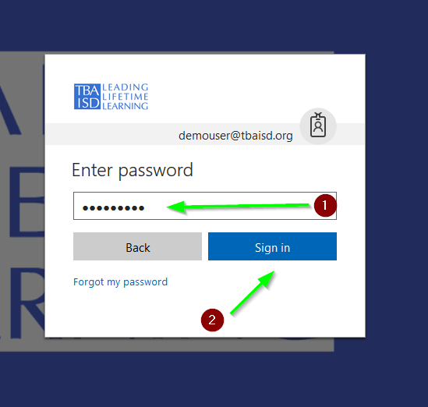

- If using a secure computer (not a public one), select ‘Don’t show this again’ and click ‘Yes’
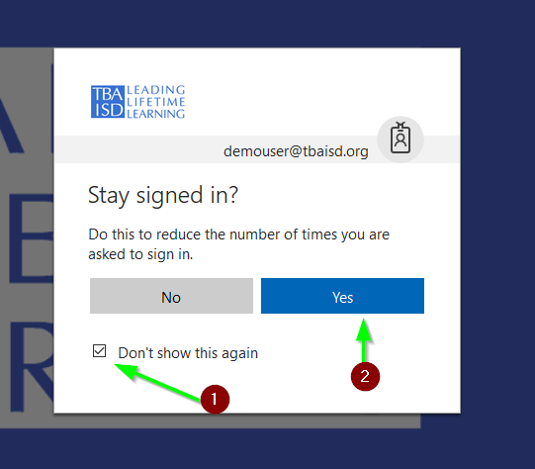

- Optional software updates may be installed. Please be patient.

- When complete, a welcome screen should appear and the Adobe products will be accessible.

- Each user can only be logged into Adobe on two computers at a time. An alert will prompt that the limit has been reached. Choose one of the following two options to continue.

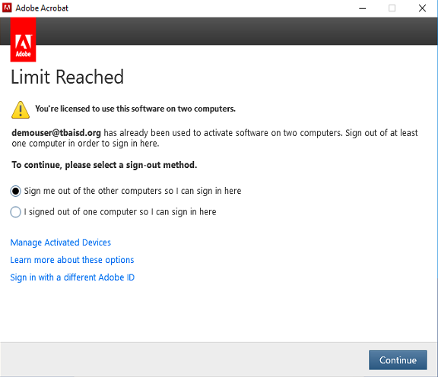

Please contact TBAISD Tech Services if further assistance is needed. Thank you.

